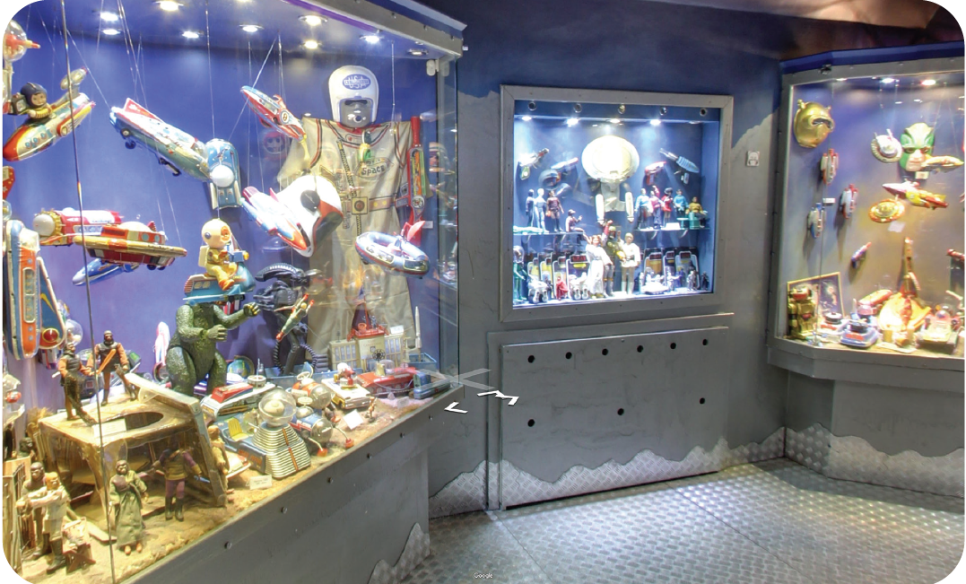

https://istanbuloyuncakmuzesi.com/pages/360-tur

